**PocketBeagle GamePup Design**

**Submitted To**

**Brian L. Evans**

**The University of Texas at Austin**

**Martin Gao**

**Texas Instruments (TI)**

**Prepared By**

**Jaelyn Bethea**

**Andrew Brown**

**Joshua Iwe**

**Bibartan Jha**

**Eeshan Sarmah**

**Darius Zinolabedini**

**EE464 Senior Design Project**

**Electrical and Computer Engineering Department**

**The University of Texas at Austin**

**April 2021**

**CONTENTS**

**TABLES………………………………………………………………………………………………….. iv**

**FIGURES................................................................................................................................................... vi**

**EXECUTIVE SUMMARY....................................................................................................................... vii**

**1.0 . INTRODUCTION………………………………………………………………………….. 1**

**2.0 . DESIGN PROBLEM STATEMENT……………………………………………………… 2**

**2.1... Design Problem Description**

**2.2... Background Information**

**2.3… Design Functionality**

**2.4… Requirements Specifications**

**2.4.1… *Input and Output Specifications***

**2.4.2… *User Specifications***

**2.4.3… *Operating Environment Specifications***

**2.4.4… *Performance Specifications***

**3.0 . DESIGN PROBLEM SOLUTION………………………………………………………... 2**

**3.1... Design Concept.............................................................................................................3**

**3.1.1… *Hardware - PocketBeagle*…………………………………………………… 3**

**3.1.2… *Hardware - GamePup Cape*…………………………………………………. 3**

**3.1.3… *Software - Production Code*…………………………………………………. 3 3.1.4… *Software - Test Code*…………………………………………………………. 3**

**4.0 . DESIGN IMPLEMENTATION…………………………………………………………… 4**

**4.1… Design Decisions**

**4.1.1… *Alternative Designs*………………………………………………………….. 4**

**4.2… Obstacles……………………………………………………………………………... 4**

**4.2.1… *Sound Driver Errors***

**4.2.2… *Running MAME on GamePup*……………………………………………... 4**

**4.2.3… *LCD Booting Issues*………………………………………………………… 4**

**4.2.4… *Device Tree Errors*…………………………………………………………… 4**

**4.3 Economic Analysis**

**4.4 Innovations During Prototype Construction Phase**

**5.0 . TEST AND EVALUATION………………………………………………………………... 5**

**5.1... Hardware Test and Evaluation…………………………………………………………**

**5.1.1… *PocketBeagle***

**5.1.2… *LEDs on the GamePup***

**5.2... Software**

**5.3... Functionality**

**6.0 . TIME AND COST CONSIDERATIONS…………………………………………………. 7**

**7.0 . ETHICAL ASPECTS OF DESIGN ……………………………………………………..... 7**

**8.0 . RECOMMENDATIONS …………………………………………………………………... 7 8.1... Future Steps**

**8.1.1… *More I/O devices***

**8.1.2… *New games***

**8.1.3… *Multiplayer***

**9.0 . CONCLUSION.... …………………………………………………………………………… 8**

**REFERENCES………..…………………………………………………………………………… 9**

*CONTENTS (Continued)*

**APPENDIX A - [Relevant Standards] ……………..…………..…………………………….. A-1**

**APPENDIX B - [Work Breakdown Structures] ..…………………………………………… B-1**

**APPENDIX C - [Linear Responsibility Chart] ...…………………………………………… C-1**

**APPENDIX D - [Gantt Chart] ...……………..……………………………………………… D-1**

**APPENDIX E - [Bill of Materials] ...………………………………………………………… E-1**

**TABLES**

1... *Table 1.User Interface Specifications………………………………………………….....................* 7

2... *Table 2.Operating Environment Specifications*…………………………………………........*..*7

3... *Table 3.Performance Specifications…………....*…………………………………………........*.*7

2... *Table 4.Sleep Time ..*........*..*

**FIGURES**

1... *Figure 1. Beaglebone PocketBeagle with Game Pup Cape.......*.......................................*............* 6

2... *Figure 2. Lithium Ion Battery………........*...........................................*........*.....*....*..........................7

3... *Figure 3. GamePup Model Screenshot....*...........................................*........*.....*....*..........................7

4... *Figure 4. Welcome Screen…………........*............................................*........*.....*....*..........................7

5... *Figure 5. Menu Screen……………........*...........................................*........*.....*....*.............................7

6... *Figure 6. Block Diagram of MainProgram……………........*................................*........*.....*....*........7

7... *Figure 7. Block Diagram of GamePup Cape Testing……………........*........................................

**EXECUTIVE SUMMARY**

The design problem that the team worked on was expanding the design of the PocketBeagle and GamePup Cape to create a handheld, portable gaming device. The aim of the project was demonstrating the capability of the PocketBeagle to be used in this manner. Another goal of the project was to add documentation for the PocketBeagle and GamePup cape, as there is currently little documentation available online. The PocketBeagle is a microcontroller with a 1 GHz processor. The GamePup Cape is an accessory for the PocketBeagle that is composed of ten buttons, a speaker, an LCD screen, and a header for the PocketBeagle.

The team initially struggled in making progress due to hardware issues as the entire team ran into faulty SD cards. Furthermore, there was a lack of understanding on how to approach the design problem due to insufficient pre-existing documentation about the PocketBeagle. During winter break the team had a meeting with Jason Kridner, the CEO of BeagleBoard (the organization that created the PocketBeagle). Kridner provided solutions to the main software issues by suggesting the team look into Advance MAME.

Upon Kridner’s advice, the software subteam used Advance MAME to run the games on the GamePup Cape. Initially, the MAME emulator ran into video formatting and sound driver issues whenever the user selected a game to play from the menu screen. The software team changed the kernel version in order to fix these obstacles and allow the Advance MAME emulator to successfully run the user-selected game.

The software subteam initially struggled with understanding how to incorporate the LVGL graphics library into the project. In order to get LVGL working on the LCD screen, the software team used a LVGL tutorial to create a basic LVGL simulation environment and then modified this environment to create the welcome and menu screens for the main project. Once the menu screen was created, the software team linked the ROMs to their respective names on the menu screen.

The hardware subteam first dealt testing all the hardware components on the GamePup Cape to make sure of their functionality. After this, the next task was integrating an external battery with the current design to allow for the gaming device to be self-sustaining. Testing was done in order to determine the battery life and how to recharge the battery. The next task was creating a 3D printed enclosure for the GamePup Cape to hide the internal components. This was modeled through the CAD software, Fusion 360, and was printed through the Craftbox 3D printer provided by UT Inventionworks.

The two main ethical considerations of the project were user data considerations and intellectual property concerns. Since multiplayer gameplay was not implemented, the team did not collect any user data. As the team used ROMs of pre-existing games, there was mild concern about intellectual property infringement, but since MAME has acquired the rights of the games from the creators, we are able to use them for non-commercial use. . Another aspect of intellectual property that was considered was the team’s code, which follows the US National Cancer InstituteTechnology Transfer Center IPR Policy standard.

For future teams undertaking a project with the PocketBeagle, the team would recommend searching for third-party resources initially, as the official PocketBeagle documentation is limited. The team would also recommend having a strong understanding of LVGL and Advance Mame before attempting to run any ROMs on the PocketBeagle. The team’s project will also serve as a good starting point for future development.

**1.0 INTRODUCTION**

This document serves to give a completed design report of the PocketBeagle GamePup project. The team outlines the motivation behind the project and the specifications that were taken into account while addressing the design problem. In this section, further information about the PocketBeagle hardware used is presented. Furthermore, the team demonstrates the solution that addresses this design problem of creating a handheld gaming device using the GamePup Cape. To explain the implementation and evaluation of this design solution, the team describes the rationale used when making decisions about the case design and choosing MAME and LVGL to implement software. Then, the team details the various obstacles faced in integrating the libraries chosen with the PocketBeagle, and the testing methods used to ensure that the results fulfilled the original design specifications. In addition, various considerations taken during the course of the project are highlighted; these considerations address concerns such as ethics, budget, safety, and time. Finally, commentary is provided on how future teams working with the PocketBeagle should approach the challenges presented by this design problem.

**2.0 DESIGN PROBLEM**

This section discusses the overall goals, motivation, and requirements behind the PocketBeagle GamePup project. This section also provides a detailed description of the design problem, the project criteria the team had to satisfy, the design functionality of the PocketBeagle, the reasoning behind choosing the software libraries that were made, and how the design functionality meets the project’s objective. Lastly, this section characterizes the many requirement specifications that were taken into account to produce the most optimal handheld gaming device.

**2.1 Background Information**

This project is sponsored by Texas Instruments, a company that specializes in semiconductors and integrated circuits. For this project, Texas Instruments provided the reference design and hardware. Through sponsoring this project, Texas Instruments aims to create a sample product for interested consumers and demonstrate a cost efficient method of small-scale game design. Another one of Texas Instruments’s objectives for this project is to expand upon the available documentation for the PocketBeagle and GamePup Cape. As of now, the PocketBeagle and GamePup Cape are not widely used boards and there is very little documentation online involving these boards. As a result, Texas Instruments hopes that this project can serve as a reference for future groups to follow when working with these boards.

**2.2 Design Problem Description**

The team is tackling the problem of expanding a “GamePup Cape” reference design into a full fledged handheld gaming device. The project goal is to design an emulator that can support the playing of multiple games. An emulator is typically a software that “emulates”, or imitates, a physical gaming system allowing the user to play any games that they have a software copy of or a software that provides the user with a set of in-built games for them to play. However, the PocketBeagle GamePup project differs from the traditional emulator in that it will integrate hardware aspects such as an external power source (battery), buttons, and a physical screen. By adding these aspects, it will allow for portability and greater ease of access for the user as they are no longer tethered to a keyboard or power source to play.

The final system must be complete with an enclosure, a battery system and a Software User Interface. Not only must the system be portable, but it should also contain sensor input capabilities (such as buttons) as well as output capabilities (a graphical display and sound) that allow users to interact with the game being played on the system. The completed project should consist of an emulator device that supports multiple games. The final device should appeal to game enthusiasts and demonstrate the capabilities of both the PocketBeagle and the GamePup Cape boards.

The PocketBeagle GamePup project is composed of two main hardware components: the BeagleBoard Pocket Beagle and the GamePup Cape from BeagleBoard.org. The Pocket Beagle is a microcontroller with a 1 GHz processor and the GamePup Cape is a hardware add-on that provides additional functionality such as buttons, joysticks, and LCD displays. Due to there being a large variety of capes, the team had a large degree of freedom in deciding how to implement the games.

Two additional hardware components of the project are an external battery (to allow for portability) and a case enclosure.

**2.3 Requirements Specification**

The requirements subsection details all of the specific criteria needed for a successful design. Included in this section are the various specification categories that make up the total requirement specifications for the PocketBeagle GamePup project. Each specification category consists of a table or figure detailing all the necessary specifications that fall into that category and its applicability to the team project design.

***2.3.1 Input and Output Specifications***

Figure 1 below labels the inputs and outputs of our system. The inputs to the PocketBeagle and the GamePup Cape are the game control buttons, the power input, and the microSD card, while the output is the LCD screen and the sound. The PocketBeagle appears in the bottom of the image under the LCD Display. The dark PCB underneath the screen is the GamePup Cape accessory we will use to prototype the system. The gameplay buttons will be interfaced using general-purpose input/output pins.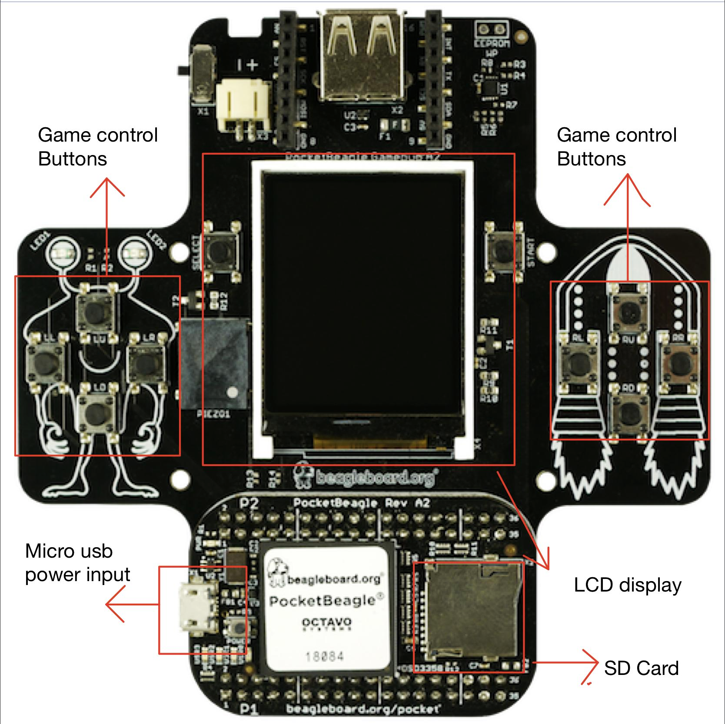

**Figure 1. Beaglebone PocketBeagle with Game Pup Cape** [1]

***2.3.2 User Interface Specifications***

One of the project’s main elements is having a user interact with the hardware to successfully play a game. As seen in Table 1below, each of the specifications refer to physical components connected to the microcontroller that allows the user to communicate with the system. The LCD Screen is used for the graphics display and can be toggled on or off. There are 10 buttons that serve as in-game controls as well as navigating the menu and settings. These send information based on a press/release basis. Lastly, there is a speaker that provides the audio for music and sound effects in-game which can be toggled between on and muted. All of these specifications are needed to provide an enjoyable gaming experience.**Table 1. User Interface Specifications**

|  |  |  |
| --- | --- | --- |
| **Specification** | **Purpose** | **Value** |
| LCD Screen | To display game graphics for the emulator | On, Off |
| Button | User controls for the game | Pressed, Released |
| Speaker | Hear audio of the game (music, sound effects, etc) | Sound On, Muted |

***2.3.3 Performance Specifications***

Table 2 below lists all testable performance parameters for our project. For each performance parameter, a description and observable value is given. Most of the performance parameters listed below are focused on the overall quality of our game. While some of these performance parameters are a little subjective (such as determining the complexity of the ROMs), overall this table still provides a quantitative estimate of how well our project performs. The quality of game and quality of game system parameters focus on the user’s experience interacting with software and hardware respectively. The audio quality, speed of display, and response time of inputs are parameters that the team will use to evaluate the performance of the software and hardware.

**Table 2. Performance Specifications**

|  |  |  |
| --- | --- | --- |
| **Performance Parameters** | **Description** | **Values** |
| Quality of Game | How fun/complex the game is | Enjoyable, playable, not fun, unplayable |
| Visual Display of Game | Graphical quality | Clear, pixelated, unclear |
| Audio Quality | Can hear all games sounds, no lag in sound, volume corresponds accordingly when changed | Audible, muffled, inaudible |
| Speed of display | Amount of visual lag while playing game | Fps |
| Response Time for Inputs | Amount of time for inputs to be received and processed | Interval of time |
| Quality of Overall Game System | Any noticeable bugs while playing game | Number of glitches/bugs in game |

**3.0 DESIGN SOLUTION**

This section of the document details the team’s design approach to creating the handheld game system. The following paragraphs provide a detailed plan of how the team addressed the specifications set forth in the design problem as well as a high level overview of the design.

**3.1 Design Concept**

The two major subsystems for the project are hardware and software. Because these subsystems were large, each subsystem is broken down into smaller modules. Each module has its own specific purpose or job within that subsystem. The following sections provide a more in-depth explanation about the subsystems, modules, and integration.

***3.1.1 System Overview***

All subsystems and their respective modules work together in order for the game emulator to function properly. Figure 2 gives a thorough system overview on how each subsystem of the project is dependent on each other. First, the user powers on the PocketBeagle and sends inputs by pressing different buttons on the GamePup Cape to select a game to play or to interact with the game currently in progress. Each input on the GamePup Cape is routed to a specific GPIO pin on the PocketBeagle. When the user sends an input, the value of the associated GPIO pin changes. Next, the main program continuously checks for a change from the PocketBeagle by calling lv_task_handler(). Once a change has been detected, the main program will update the LGVL frame buffer to show the new and appropriate display for the LCD screen on the GamePup Cape. While the external battery might appear independent from the other hardware and software components, the battery makes the project portable and provides a power source for the PocketBeagle. The following sections will provide a more detailed discussion of the modules within each subsystem and how those modules work together to create a portable game emulator.

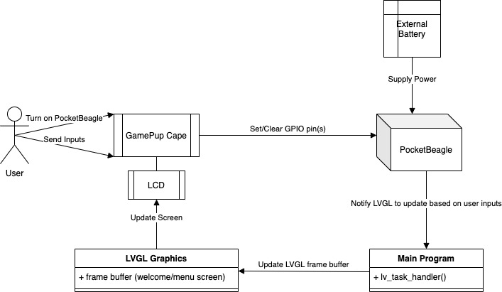

**Figure 2. Block Diagram of Software and Hardware Modules Working Together**

***3.1.2 Hardware - PocketBeagle***

The hardware subsystem contains the PocketBeagle, the GamePup Cape, an external battery, and a case enclosure. The PocketBeagle runs a Linux operating system by interacting with the image stored on a MicroSD card. The PocketBeagle consists of 72 pin headers to allow accessories to connect, a microUSB port to allow for connection to a computer, and a microSD connector. The PocketBeagle also contains a 1 GHz processor to process all instructions allowing the project to function properly. The PocketBeagle hardware provides support for the hardware components of the game and the software for the game itself.

***3.1.3 Hardware - GamePup Cape***

Another other hardware component in the project is the GamePup Cape, which is a hardware extension of the PocketBeagle. The GamePup Cape has 72 pins that allow for connection to the PocketBeagle. As a result, the team can only interface with the GamePup Cape by connecting its GPIO pins to the PocketBeagle header. The input features of the GamePup Cape are 10 user programmable buttons and the output features are a sound buzzer, 2 LEDs, and a 160x128 color LCD. This hardware subsystem is instrumental because it allows users to interact with the emulator.

***3.1.4 Hardware - Battery***

The third hardware component in the project is the external battery. One of the key aspects of the team’s design problem was to design the GamePup Cape to be handheld. The main implication of the device being handheld is that it is also portable. When the PocketBeagle is powered through USB cable, it is no longer portable since it is required to be within range of a computer. Therefore, the battery is an integral component of the design as it enables portability for the system.

The team chose the EEMB 3.7V, 2500mAh Lithium ion Polymer Battery to power the PocketBeagle, as it has the correct polarity. This battery connects to the system through a JST port on the GamePup Cape which can only be connected in one orientation. The PCB traces on the cape for the positive and negative terminals in the battery are the opposite of most batteries the team initially considered, so choosing a battery with the correct polarity was important. The battery has a one hour battery life and is charged via the micro-usb port located on the PocketBeagle.

***3.1.5 Hardware - Case***

The last hardware component is the case enclosure. The case was designed through the cloud-based 3D modeling software Fusion 360 and using 3D printing facilities provided by the Texas Inventionworks at UT Austin. The 3D printer used is the Craftbox XL and the material used to print is ABS Plastic. The printers provided had a minimum thickness tolerance of 1/16th of an inch, or 1.5875 mm. Any thickness smaller than this tolerance would not be entirely accurate.

The PocketBeagle and GamePup were first measured and modeled into Fusion 360 in order to get accurate 3D representation. This is seen in Figure 3 below. The bottom blackbox represents the dimensions of the PocketBeagle while the top blackbox represents the dimensions of the USB and battery ports.

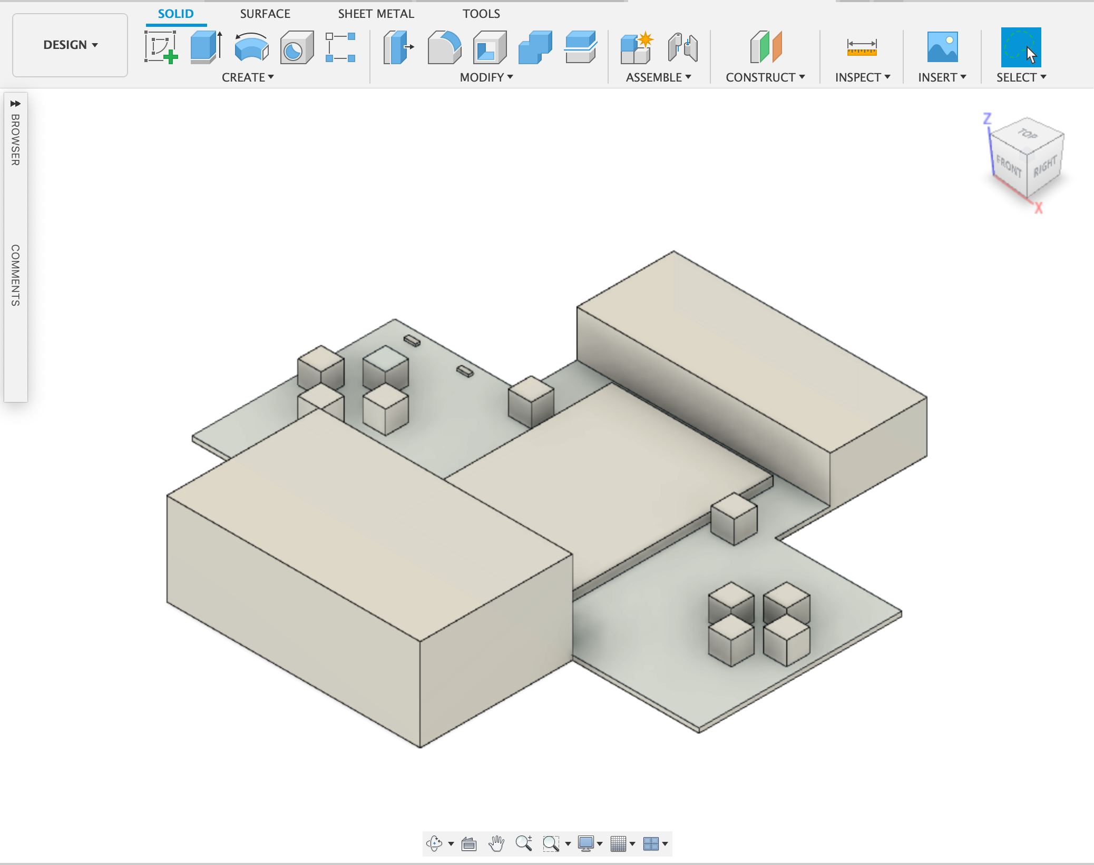

**Figure 3: GamePup Model**

The actual case is divided into two major components: the base and the top, as seen in Figures 4.1 and 4.2 below. The base is a solid piece of ABS plastic in which the GamePup is first placed. This also has a cutout for the battery placement and subsequent wires. The top has cutouts for all the buttons, LEDs, the LCD screen, as well as any ports available. Both components were modeled to have a 2 mm thickness throughout, allowing for a greater amount of precision with a lesser amount of total material.

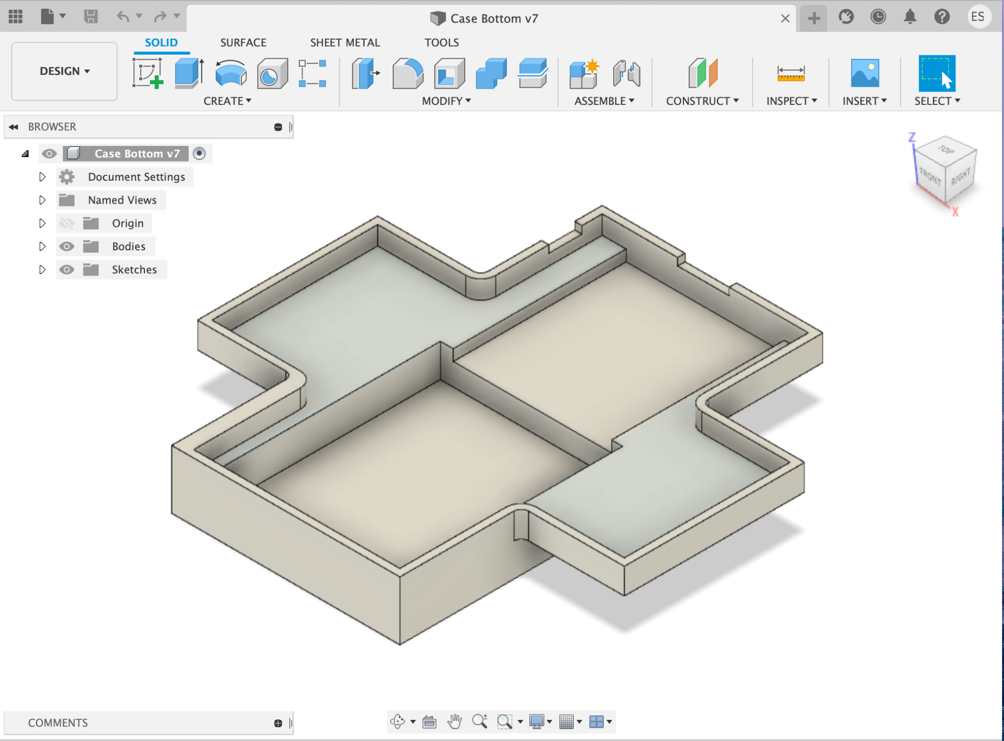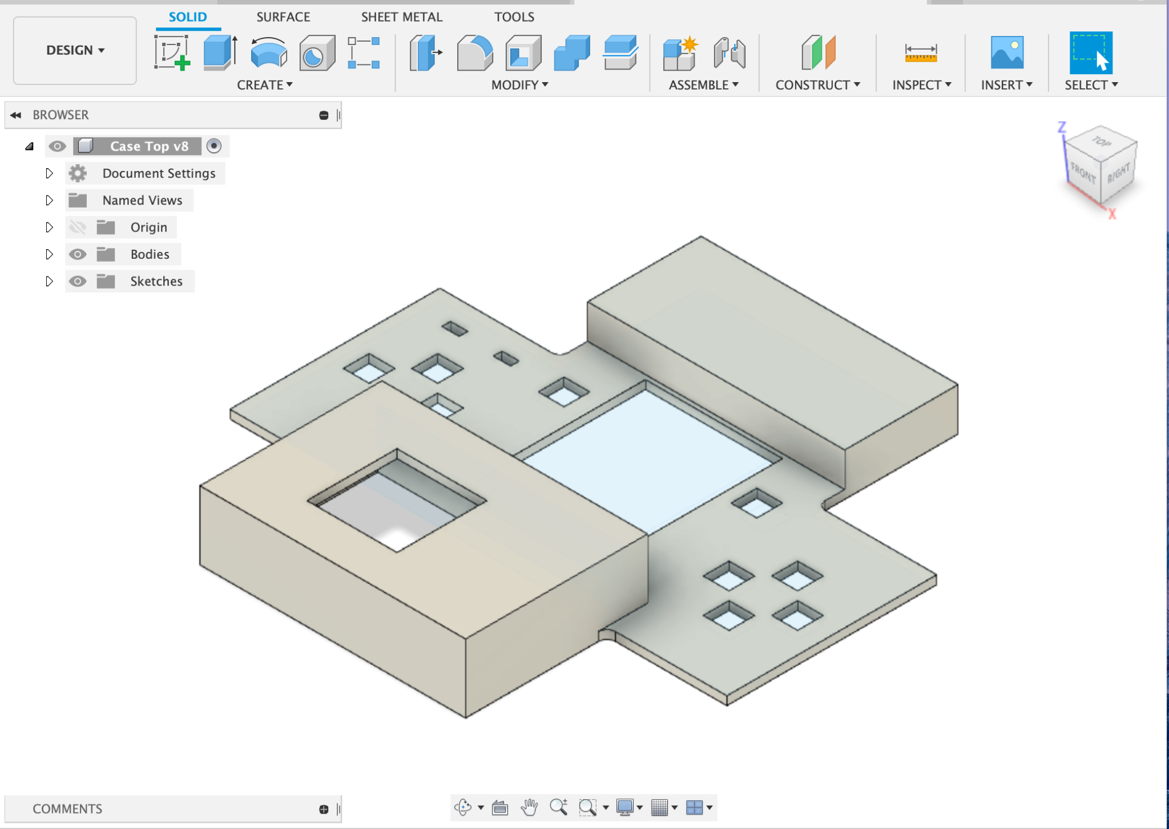

**Figure 4.1: Base of Case Figure 4.2: Top of Case**

***3.1.6 Software - Display***

The software component consists of the display on the LCD screen and the main program code used to take user input on the menu screen and run the games. The display on the LCD screen utilizes a variety of different customizable GUI elements from the LVGL graphics library [7].

One LVGL element used is the message-box. This message-box is used for the welcome screen, and shows the text “Welcome to Pocketbeagle”. This welcome screen auto-closes after 5 seconds in order to reveal the menu. Figure 5 shows the message box on the welcome screen.

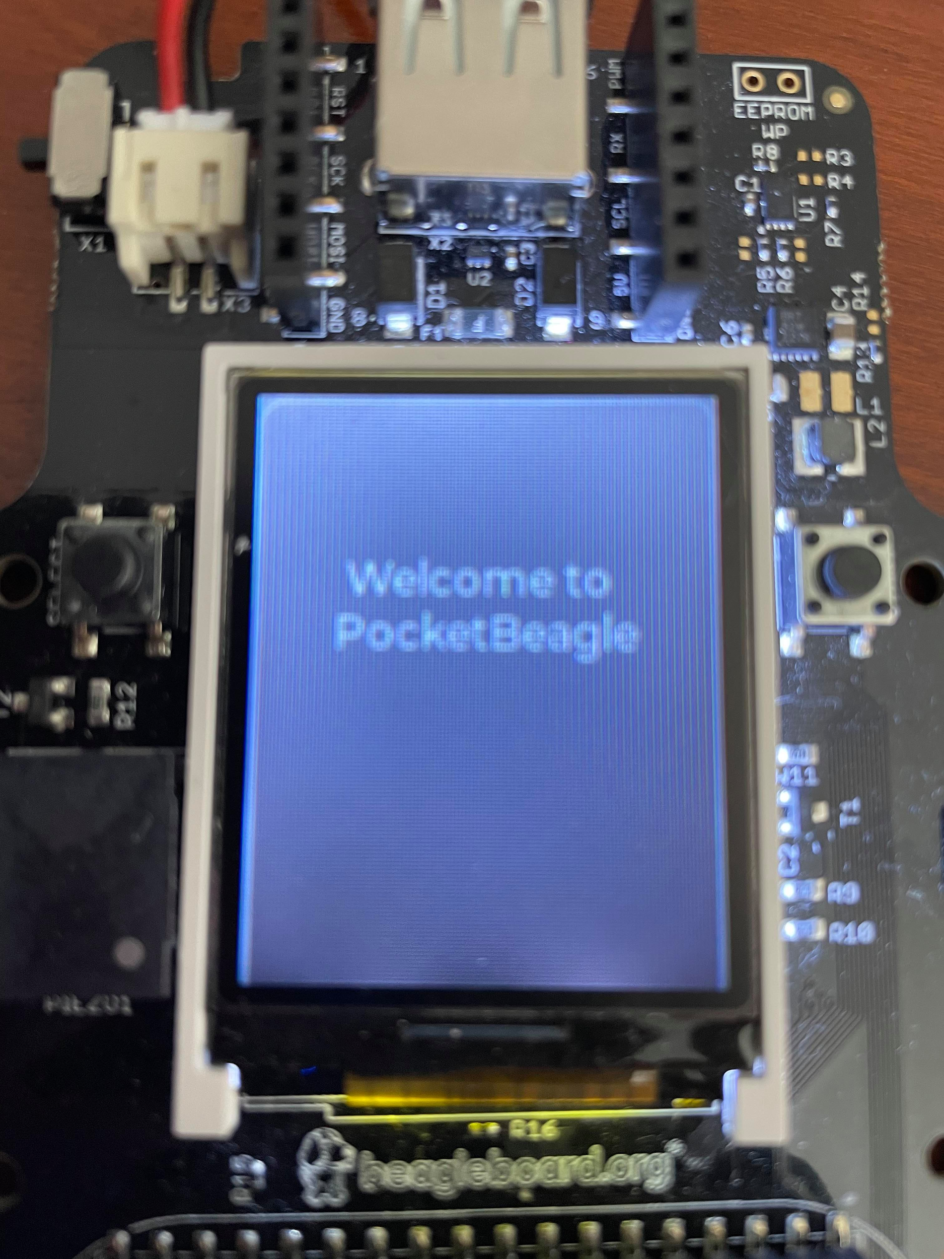

**Figure 5. Welcome Screen**

The LVGL element used for the menu-screen is the roller. The roller displays the list of games that the user can play, and highlights the user’s currently selected option. Figure 6 shows the roller on the menu screen.

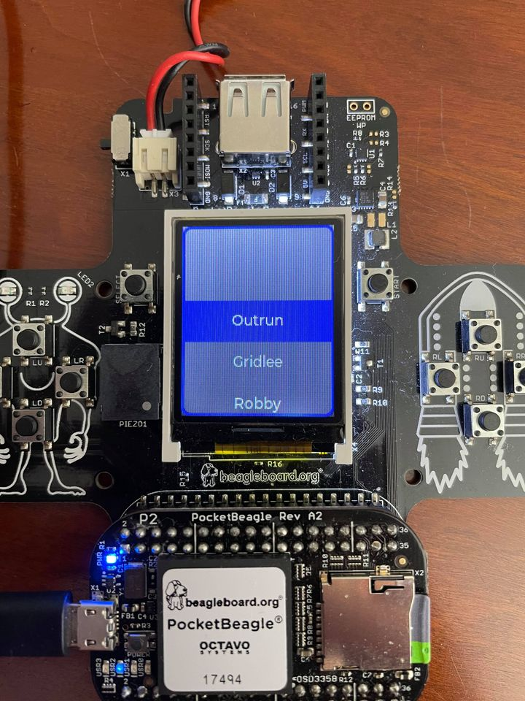

**Figure 6. Menu Screen**

***3.1.7 Software - Main Program***

The second part of the software component is the main program itself. The main program calls different functions to display our welcome screen and allow users to select a game to play from the menu screen.

First, the lv_init() function initializes all of the necessary LVGL components. This function initializes the memory layout, file system, default colors, and animations in order for the graphics library to function.

Second, the fb_dev() function initializes the frame buffer. The frame buffer contains the contents of what will be displayed on the LCD screen. fbdev_init sets the dimensions of the frame buffer and the number of bits allocated for each pixel on the LCD screen. The function also maps the frame buffer to memory and initializes all of its contents to 0.

Third, the lv_ex_get_started_1() function calls the find_roms() function, which stores the names of all the ROMS stored in the file system. Next, lv_ex_get_started_1() initializes the message box and roller. The message box is given the appropriate colors and text to display our welcome screen. The roller is given a list of games from the find_roms() function to display all of the options of games for the menu screen.

Finally, the main program continuously calls lv_task_handler() in a while(1) loop. In doing so, the main program is able to process user inputs once again each time the user exits a game and returns back to the menu screen. The main program also includes a wait period after the lv_task_handler is called to allow the LVGL to update appropriately.

Figure 7 below illustrates how the main program is executed to run our project. The main calls lv_init(), fbdev_init(), and lv_ex_get_started_1() to initialize the graphics and roms. Once those functions are finished executing, the main program will continually call lv_task_handler() and wait for user inputs as the user interacts with our simulator.

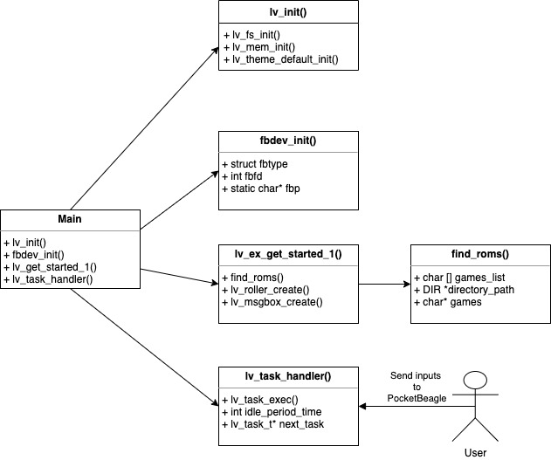

**Figure 7. Block Diagram of Main Program**

**4.0 DESIGN IMPLEMENTATION**

This section of the document details the various factors that led to the team’s final design solution. The following paragraphs explain the design decisions made during the course of the project and the modifications that were made from the original project ideas. Furthermore, this section covers the obstacles faced and the adjustments that the team had to make in response to these obstacles.

**4.1 Design Decisions**

In order to create a great user experience, the project needed to have high quality graphics on the LCD screen. In order to avoid rebuilding a graphics library from scratch, the team performed research to find a graphics library compatible with the Linux framebuffer and the display size of the ST7735 (128*160 px). The team decided on an open source graphics library called Light and Versatile Graphics Library (LVGL). This library was chosen because it had a small memory footprint suitable for embedded systems. The library also had extensive documentation, which helped speed up development. Additionally, the team needed a game engine that could run on the limited constraints of the PocketBeagle. By suggestion of the team’s faculty mentor, the team sought a way to play retro style games on the GamePup via an emulator. The team chose the emulator Advance MAME [6] because it was portable on Linux and had a wide range of playable games that worked on the PocketBeagle.

***4.1.1 Alternative Designs***

There were a variety of possible alternate design implementations that the team considered during the course of the project. One area in which the team looked through multiple design options is the menu screen graphics. While the team ultimately eventually the LVGL graphics library, another library considered was Qt. This is a robust graphics library referenced in the book “*Exploring BeagleBone: tools and techniques for building with embedded Linux*”. Exploring Beagle bone discusses. However, LVGL was ultimately used rather than Qt because the documentation for LVGL was more understandable and simple. Qt appeared to be a great alternative but presented a steep learning curve.

Another area in which the team looked through multiple design options is running games on the PocketBeagle. While the team eventually used the MAME emulator to run games from pre-built ROM files, an alternative considered was Microsoft MakeCode. MakeCode is a platform through which programmers can build their own games. While MakeCode has its own advantages in that programmers don’t have to search for existing game files, the team decided to use MAME instead in order to keep the focus on hosting games on the PocketBeagle. Since building new games would definitely have taken more time than using pre-built MAME games, the team ultimately decided to use MAME due to time constraints.

**4.2 Obstacles**

The team faced a plethora of challenges during the course of the project, and these challenges forced the team to make modifications to the original design plan.

*4.2.1 Sound Driver Errors*

A major obstacle the team faced during the integration of the game engine was the inability to hear sound. When reading the log file, the team discovered that an ALSA error appeared everytime when trying to start the MAME emulator. With this error, the team could not get the game to initialize. After much research and reaching out to third party resources, the team realized that the kernel that was currently being used was the newest update and it was the kernel that was contributing to the ALSA errors. The kernel version was 4.19.94-ti-r42. The modification the team had to make was installing an older kernel version and creating a program that tested the sound. The kernel version the team used was Linux 4.14.108-ti-r137. The program that tested the sound had to be called at least once when the board was turned and before initializing the game.

*4.2.2 Running MAME on GamePup*

Another challenge the team faced when integrating the emulator was getting the graphics to display on the GamePup when run. The first documented error was that of MAME not being able to find a suitable video format. After debugging and discussing with members of a PocketBeagle slack channel, the team realized that the emulator needed to run directly on the PocketBeagle as opposed to the web IDE. To get the graphics to display properly, the team had two options: connect an external keyboard and run the program directly from PocketBeagle or create a service routine that would automatically run the program that was written on power up. Taking into consideration that an external keyboard did not necessarily align with the team goal of having a portable gaming device, the team decided to create a service routine.

*4.2.3 LCD Booting issues*

To ensure that the welcome and menu screens show up on the LCD every time the PocketBeagle is powered on, the team created a .service file which runs various files necessary for the game system. The .service file first runs speaker.sh, which enables audio. Then, the .service file runs main.c, which runs the software component for the PocketBeagle as described in sections 3.1.5 and 3.1.6. However, upon powering on the PocketBeagle, the team realized the .service file was calling main.c before speaker.sh finished running. As a result, main.c was not able to write to the LCD framebuffer, and the LCD was showing neither the welcome nor menu screens. In order to fix this issue, the team decided to add a “sleep 20” command in the .service file right after calling speaker.sh so that speaker.sh is given enough time to finish running before the .service file calls main.c.

*4.2.4 Device Tree Errors*

A device tree is a file that assigns specific GPIO pins to a specific piece of hardware. PocketBeagle utilized the device tree file to create a universal system of assigning pins across all the capes. The initial device tree that was present when the team initialized Cloud9 was the *BBORG_GAMEPUP-00A2.dts.* The assignments made in this device tree prevented the team from interfacing with the buttons and LEDs. The team updated to the *BBORG_GAMEPUP-00A4.dts* as it was a more updated version of the initial file. However, the device tree errors remained. After this, the team created a custom device tree file in order to free up the premade GPIO connections to the buttons and LEDs, which allowed for the team to write software to interface with them.

**4.3 Economic Analysis**

In regards to total cost of production, the current design solution is cost efficient as it does not require any additional I/O devices for the user to play the games. The cost for each PocketBeagle plus add-ons totals $97.54. Located toward the end of the document, Appendix E provides a more detailed breakdown of the costs per item. After this, there are no additional costs required to play games, allowing the user to play any game they have a .ROM file of. The case was constructed using free 3D printing facilities provided by UT Inventionworks at UT Austin.

The team also had to make some tradeoffs between parts because of cost and performance. While the majority of the parts of the project (such as the PocketBeagle and GamePup cape) were pre-determined by Texas Instruments, the team had to choose between a variety of options for the battery. The team had to choose a rechargeable battery that had the same connectors as the GamePup cape, fit in our enclosure, and had a high enough capacity for extended gameplay. After comparing the price and size of each battery, we decided on a 3.7 Lithium polymer battery from amazon. Each battery costs $17.18 amounting to a total of $103.08 for six team members.

**4.4 Innovations during prototype construction phase**

Innovations made in software during the prototype construction phase were mainly to handle the obstacles documented in Section 4.2. The use of an external keyboard and the eventual creation of a service routine allowed for the graphics and advance MAME to run properly. In order to fix LCD booting issues, a service file was created and delays were used to allow for synchronization between the speaker file and main.c. Lastly, understanding the device tree overlay and creating the custom device tree file allowed for more control over the GPIO pins on the GamePup.

During prototyping the final GamePup case, innovations were made to make the case more efficient in terms of print time and usability. Initially, there were initially three components: the base, the top, and the battery enclosure. However, having a separate battery enclosure took extra time and material during construction and was not efficient. Therefore, in the second version of the case, the base has a divot for the battery, while the GamePup lies on top. This allows for a more compact design with less moving parts.

**5.0 TEST AND EVALUATION**

When testing and evaluating the success of the PocketBeagle GamePup design, the team focused on 3 primary categories: hardware, software, and functionality. The tests on hardware focused on ensuring that the hardware the team was using initially worked (was not defective) and continued to work throughout the process. Software testing and evaluation focused on how the code interacted with the hardware. Lastly, the tests on functionality were based on how well the overall design worked. These categories combined helped determine how successful the team design was in meeting it’s requirements.

**5.1 Hardware Test and Evaluation**

Ensuring that the hardware worked properly was an early evaluation the team looked for. After having issues with malfunctioning SD cards early on, it was important to make sure that everything was working properly and discovering issues early before moving further into implementing our design. The main hardware components we tested were the PocketBeagle and the LEDs on the GamePup Cape.

*5.1.1 PocketBeagle*

To make sure the PocketBeagle, the brain that runs the operating system, was functioning correctly, the team relied on a few tests . The first test was taken directly from the Exploring Beaglebone book. . According to the book, when the board is connected to a power source the following criteria needed to be met: the PWR LED needed to light up and stay lit up and the USR0 LED needed to be consistently blinking. The PWR LED indicates that the Pocket beagle is indeed receiving power and the USR0 flashes in a heartbeat sequence to indicate that the board is alive. Another test that was run in the beginning to test Pocket beagle was prewritten code. Cloud9 (the IDE) came with code written in different languages that allowed a user to test the LEDs on the PocketBeagle. These tests were helpful in making sure the LEDs on the PocketBeagle worked properly.

*5.1.2 LEDs on the GamePup*

Using the Exploring Beaglebone book, the team was able to find code that could interface the LEDs on the PocketBeagle and on the GamePup Cape. These LEDs were initially tested successfully by powering them at various duty cycles. However, after many of the SD cards were damaged, the team was no longer able to access the directory that contained the GamePup Cape LEDs on Cloud9. In order to learn about other methods to interface the LEDs, the team utilized Adafruit_Blinka, a github repository that contains drivers for LEDs on systems that run Linux. As the PocketBeagle is a linux based microcontroller, the team was able to adapt the code in the digitalio package to interface the LEDs on the GamePup Cape. These LEDs were tested through the use of various scripts that mapped a specific LED duty cycle to a button.

**5.2 Software**

The main software aspect the team tested involved the service file. The service file is what allows the program to run automatically when the board is applied to a power source. In the service file, there are calls to programs where each program is written to accomplish a specific purpose to set up the board. The team ran into the issue of two programs trying to access the framebuffer at the same time. In order to solve this, the sleep(x) function was placed in between functions so that the first program had time to finish running before moving on to the next program. The following table below shows the different sleep amounts tested (in seconds) to see what the lowest sleep value could be used while making sure there was no conflict between the two programs accessing the framebuffer.

**Table 3. Sleep Time Success**

|  |  |
| --- | --- |
| **Amount to Sleep(s)** | **Success** |
| **10** | **no** |
| **20** | **yes** |
| **30** | **yes** |
| **40** | **yes** |
| **50** | **yes** |
| **60** | **yes** |

**5.3 Functionality**

In order to test the GamePup Cape’s functionality, the team applied different user inputs and verified whether the software received these inputs. The block diagram in Figure 3 demonstrates how a user can interact with the GamePup Cape and test its functionality. As shown in the diagram, a user could press one of GamePup Cape’s buttons to move a character on the screen. The software module will recognize, receive, and assess the validity of this hardware input. If the input is valid, the software will dispatch a command to the GamePup Cape to change the screen. The GamePup Cape will then modify the LCD Screen to show that the character has now been moved.

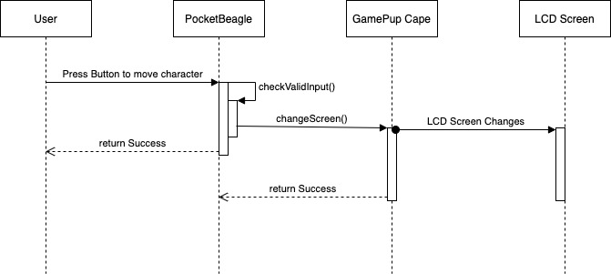

**Figure 7. Block Diagram of GamePup Cape Testing**

**5.4 User Experience**

In order to test the user’s experience of the design, our team created a 10 question survey that the user would fill out after playing on the device. The purpose of the survey was to receive user feedback about our team design. Shown below is an image of the user experience survey.

|  |  |  |  |  |  |  |
| --- | --- | --- | --- | --- | --- | --- |
|  |  | **Strongly Agree** | **Agree** | **Neutral** | **Disagree** | **Strongly Disagree** |
| **1** | I thought the system was easy to use |  |  |  |  |  |
| **2** | I liked the game selection |  |  |  |  |  |
| **3** | I found the system unnecessarily complex |  |  |  |  |  |
| **4** | I felt confident using the system |  |  |  |  |  |
| **5** | Gaming graphics were clear and visible |  |  |  |  |  |
| **6** | The system is easy to learn |  |  |  |  |  |
| **7** | I felt comfortable holding the device |  |  |  |  |  |
| **8** | I found the system cumbersome to use |  |  |  |  |  |
| **9** | Overall, I am satisfied with this system |  |  |  |  |  |
| **10** | I would want to use the system again |  |  |  |  |  |

**Figure 8. User Experience Survey**

Unfortunately, due to COVID and social distancing, our team was only able to survey 9 people. See Appendix F for the results of each survey question. While the results of the survey gave a majority of positive feedback, the survey also showed that there is still room to enhance our team’s design further so users can have the ultimate experience.

**6.0 TIME AND COST CONSIDERATIONS**

During the early phases of the project, the project ran behind schedule due to the lack of pre-existing documentation for the PocketBeagle. In order to form a greater understanding of how to interface with the PocketBeagle during the first few months of the project, the team conducted external research by searching through pre-existing documentation online and reaching out to experts such as BeagleBone CEO Jason Kridner. Since the first few months were spent learning about the PocketBeagle, the team was not able to begin implementing the actual design solution until winter break. Due to the limited time left, the team made several design changes to ensure that the project was finished on time. One design change was to use pre-built game files rather than creating games from scratch. Another design change was to use the LVGL graphics library rather than Qt; while the Qt library is more robust and had more available features, the LVGL was faster to learn.

The cost considerations were far less pressing as the project fell below the budget constraints. A full breakdown of the bill of materials is seen in Appendix E. The budget given for the project was $1000 which was not reached. This project was generally cost-efficient as it was built on low cost materials. One consideration however is the team’s access to free 3D printing facilities provided by Texas Inventionworks at The University of Texas at Austin. This was used to create the case for the GamePup. People working on similar projects may not have these provided facilities and would need to adjust accordingly.

**7.0 ETHICAL ASPECTS OF DESIGN**

At the beginning of the project, one major ethical consideration in the project was user privacy. This is primarily because one of the stretch goals was to integrate multiplayer capabilities to the game emulator system. If two or more players were to connect with each other from multiple PocketBeagles, the issue of protecting individual user information becomes relevant. Ultimately, since the stretch goal of a multiplayer system was not accomplished, the team did not address this ethical concern. However, future teams hoping to create a multiplayer system will have to address this concern in their design by following the UT Austin Information Resources Use Policy (Appendix A).

Another ethical consideration in the project was control of intellectual property, which was important because the team used pre-existing games created by other developers on the PocketBeagle. In order to ensure that no copyrighted work was being used, the team made sure to only use open-source games from MAME who acquired the rights to the games for non-commercial use. Additionally, the control of intellectual property is important when addressing the protection of the software written by the team. As students at UT, the team has a license for access to use Fusion 360, a CAD software. The team’s software is open-source and will be added to the BeagleBoard.org Github, so future teams can freely use and distribute the software. In regards to intellectual property, this project follows the Technology Transfer Center IPR Policy standard (Appendix A).

**8.0 RECOMMENDATIONS**

Though the team was successful in creating a game emulator using the PocketBeagle, future teams can continue the work on this project in order to expand and improve the emulator system. The team has provided a list of suggested resources that proved to be most useful during the project. Furthermore, the team has provided a series of future steps that other teams can attempt.

**8.1 Resources to consult**

The following table shows some of the third-party resources used by the team in order to learn how to interface with the PocketBeagle and create the emulator. Future teams are suggested to consult these resources for the purposes described in the table.

**Table 4. Resources**

|  |  |
| --- | --- |
| **Resource** | **Where it helped** |
| “*Exploring BeagleBone: tools and techniques for building with embedded Linux*”, by Derek Molloy | Interfacing with and testing different parts of the GamePup Cape such as LEDs, speaker, buttons, and LCD |
| RetroArcade | Adding MAME to PocketBeagle |
| LVGL | Creating graphics on LCD screen |

**8.2 Future Steps**

The team had several stretch goals that were ultimately not accomplished due to time constraints. Future teams can work towards these goals in order to further enhance the final design.

*8.2.1 More I/O devices*

The team had a stretch goal of implementing additional hardware attributes. These hardware attributes would have consisted of added input features (such as joysticks) that would make the gaming experience more enjoyable. In order to integrate these input features into the current design, future teams will need to wire these devices to the PocketBeagle and write software headers to allow these devices to communicate with the PocketBeagle.

*8.2.2 New games*

In addition to adding more I/O devices, the team also had a stretch goal of creating new games from scratch. Having the ability to create a game adds another layer of capability to the design and gives the user more creative control.Ultimately, the team only used pre-built games from MAME-based ROM files. As explained in section 4.1.1, future teams can use the Microsoft MakeCode platform in order to program new games that can be played on the PocketBeagle.

*8.2.3 Multiplayer*

The team also planned to integrate multiplayer gameplay into the final design so that users can play games with each other from multiple PocketBeagles. To add wireless network capabilities, future teams can connect the PocketBeagle to a cloud-based server by attaching a WiFi module. Future teams must also make sure that the pre-built games support multiplayer gameplay.

**9.0 CONCLUSION**

In summary, the team successfully designed a handheld gaming system that incorporates the PocketBeagle and GamePup Cape. The final design consists of 12 retro style games that a user can choose from along with buttons for game selection and movement. Additionally, the game system provides audio throughout gameplay. With the use of a battery, the system is completely portable and can easily fit inside a small bag. Also, the device does not require a user to rely on a computer as a power source or an internet connection. . Lastly, the final design consists of a 3D printed case that encloses the GamePup Cape and the battery.

Looking towards the future, there are many ways to expand upon the team’s current PocketBeagle design. Some team suggestions include: incorporating additional I/O devices, more up-to-date games, and multiplayer gameplay functionality. Throughout this process, the team managed to create significant documentation detailing the team’s understanding of the two technologies. Now, future teams can utilize the team’s finding as a resource to further expand the capabilities of the PocketBeagle and GamePup Cape.

**REFERENCES**

[1] D. Molloy, *Exploring BeagleBone: tools and techniques for building with embedded Linux*, Second. Indianapolis, Indiana: John Wiley & Sons, Inc., 2019.

[2] Beagleboard.org. 2020. *Beagleboard.Org - Capes*. [online] Available at: <https://beagleboard.org/capes> [Accessed 30 November 2020].

[3] Techtransfer.cancer.gov. 2017. IP Sample Plan #5 | NCI Technology Transfer Center | TTC. [online] Available at: [Accessed 1 October 2020].

[4] Security.utexas.edu. 2020. INFORMATION RESOURCES USE AND SECURITY POLICY. [online] Available at: [Accessed 1 October 2020].

[5] Statutes.capitol.texas.gov. 2019. GOVERNMENT CODE CHAPTER 552. PUBLIC INFORMATION. [online] Available at: [Accessed 1 October 2020]

[6] Arakiel. *Retro Arcade: Get Your Game On With Pocketbeagle*, 2018. [Online]. Available: https://www.electromaker.io/project/view/retro-arcade-get-your-game-on-with-pocketbeagle. [Accessed: 22-Mar-2021].

[7] LVGL. “Welcome to the documentation of LVGL!,” *Welcome to the documentation of LVGL! - LVGL documentation*, 16-Mar-2021. [Online]. Available: https://docs.lvgl.io/latest/en/html/index.html. [Accessed: 22-Mar-2021].

**APPENDIX A: Relevant Standards**

Appendix A - Applicable Standards

**TECHNOLOGY TRANSFER CENTER IPR POLICY**

<https://techtransfer.cancer.gov/intellectualproperty/ip-information-grantees-contractors/sample-ip-management-plans/ip-sample-plan5>

The Technology Transfer Center IPR Policy provides information in regards to the following:

1. **Definitions**
   1. Intellectual Property
   2. Owner
2. **Ownership**
3. **Oversight of Project IP**
4. **Dispute Handling**

**Definitions**

***Intellectual Property:***

Intellectual Property means technical information, inventions, developments, discoveries, know-how, methods, techniques, formulae, algorithms, data, processes and other proprietary ideas, and any other legally protectable information, including computer software.

***Owner:***

Owner refers to a party, public or private, having a legal assignment of right to Intellectual Property, as provided in the Bayh-Dole Act (35 U.S.C. § 200 et seq.).

**Ownership**

Each Party shall retain title and all legal rights to research data and intellectual property developed solely by members of that Party. A Party shall have the right to practice another Party’s intellectual provided the following conditions are met:

1. The latter agrees in writing to such use; and
2. The former practices the IP solely for work performed in collaboration with the latter

**Oversight of Project IP**

Each Party will oversee implementation of this plan and will manage:

1. Monitoring disclosure with respect to intellectual property;
2. Seeking, as needed, potential third-party licensees for intellectual property;
3. Dispute resolution as described in the “Dispute Handling” section;
4. Facilitating timely and accurate reporting regarding creation of new intellectual property and use of other parties’ intellectual property

**Dispute Handling**

Any dispute between Parties relating to intellectual management shall be referred to the Parties’ respective leaders for resolution, within a reasonable period of time and in a fair and equitable manner, taking into consideration any laws, statutes, rules, regulations or guidelines to which the involved Parties are subject.

[3]

**INFORMATION RESOURCES USE AND SECURITY POLICY**

<https://security.utexas.edu/policies/irusp>

The UT Austin Information Resources Use and Security Policy provides information about the following:

1. **Definitions**
   1. Backup
   2. Confidential Data
   3. Information Resources
   4. Personally Identifiable Information (PII)
   5. Portable Computing Device
   6. User
2. **Policy Statement**
3. **Applicability**
4. **Compliance with State Law**

**Definitions**

***Backup***

Copy of files or applications made to avoid loss of data and facilitate recovery in the event of a system failure or other data loss event.

***Confidential Data***

Data/information that is exempt from unauthorized disclosure under applicable State law, including the Texas Public Information Act, and Federal laws.

***Information Resources***

All computer-related activities involving any device capable of receiving, storing, managing, or transmitting data. Additionally, it is the procedures and software that are designed, built, operated, and maintained to create, collect, record, process, store, retrieve, display, and transmit information.

***Personally Identifiable Information (PII)***

Information that alone or in conjunction with other information identifies an individual. PII includes, but is not limited to: an individual’s name; a Social Security number; a date of birth; a government-issued identification number; a mother’s maiden name; unique biometric data (including an individual’s fingerprint, voice print, and retina or iris image); a unique electronic identification number, address, or routing code; or a telecommunication access device.

***Portable Computing Device***

Any easily movable device capable of receiving, transmitting, and/or storing data. These include, but are not limited to: notebook computers, handheld computers, tablets (e.g., iPads, etc.), PDAs (personal digital assistants), pagers, smartphones (e.g., iPhones, etc.), Universal Serial Bus (USB) drives, memory cards, external hard drives, data disks, CDs, DVDs, and similar storage devices.

***User***

An individual, automated application, or process that is authorized by the Owner to access the resource, in accordance with Federal and State law, university policy, and the Owner's procedures and rules.

**Policy Statement**

* Protect Information Resources based on risk against accidental or unauthorized disclosure, modification, or destruction and assure the confidentiality, integrity, and availability of data
* Apply appropriate physical and technical safeguards without creating unjustified obstacles

**Applicability**

This policy is applicable to the following:

* All Information Resources owned, leased, operated
* All individuals accessing, using, holding, or managing Information Resources [4]

**Compliance with State Law**

Information that is collected is subject to Section 552.139 of the Texas Government Code and is therefore confidential by law. [5]

**APPENDIX B: Work Breakdown Structures**

Appendix B - Work Breakdown Structures

1. Software
   1. Establish proper connection with Linux
   2. Finalize programming language (Python ?)
      1. Select the best and most high level programming language possible
   3. Game Design
      1. Final selection of 2-3 games to incorporate
         1. Analyze which games work within the design constraints of our project
   4. Graphical User Interface
      1. Work out display issues
         1. Get LCD screen to turn on
2. Hardware
   1. External battery implementation
      1. Select proper battery
   2. Map button inputs
   3. Map LED outputs
   4. Proper PocketBeagle setup
      1. Successfully recognize PocketBeagle drive on device
         1. Access to Cloud9
      2. Connect PocketBeagle to the Internet
3. Integration
   1. Hardware and software integration
      1. Modify the code of chosen games to work with our hardware
         1. Ensure user functionality correctly
   2. Consider user functionality
      1. Proper buttons are coded that make it easier for the user to interact while playing a game
4. Testing
   1. Hardware
      1. Test basic functionality of:
         1. Buttons
         2. LCD screen
         3. SD card flashing
         4. LEDs
         5. External battery
         6. USB input
   2. Software
      1. Lag times between input and display
      2. Game logic implementation
      3. GUI implementation functionality
5. Presentation/Demo
   1. Build slideshow explaining design problem and solution
   2. Record workable demo of game functionality
   3. Decide on presentation organization

**APPENDIX C: Linear Responsibility Chart**

Appendix C: Linear Responsibility Chart

|  |
| --- |
| **Key for table below** |
| 1 = primary responsibility |
| 2 = support/ work |
| 3 = consult/review |

|  |  |  |  |  |  |  |
| --- | --- | --- | --- | --- | --- | --- |
|  | **Darius Zinolabedini** | **Joshua Iwe** | **Eeshan Sarmah** | **Andrew Brown** | **Bibartan Jha** | **Jaelyn Bethea** |
| **1. Software** | **2** | **2** | **2** | **1** | **1** | **1** |
| 1.1 Establish proper connection with Linux | **2** | **2** | **1** | **1** | **1** | **3** |
| 1.2 Finalize programming language (Python?) | **3** | **3** | **3** | **1** | **2** | **2** |
| 1.2.1 Select the most high level programming language possible | **3** | **3** | **3** | **1** | **1** | **1** |
| 1.3 Game Design | **2** | **2** | **2** | **2** | **1** | **2** |
| 1.3.1Final selection of 2-3 to incorporate | **2** | **1** | **2** |  |  |  |
| 1.3.1.1 Analyze which games work within design constraints | **3** | **3** | **3** | **2** | **2** | **1** |
| 1.4 Graphical User Interface | **3** | **3** | **3** | **1** | **2** | **2** |
| 1.4.1 Work out display issues | **2** | **2** | **2** | **2** | **2** | **1** |
| 1.4.1.1 Get LCD screen to turn on | **2** | **1** | **2** | **2** | **2** | **1** |
| **2. Hardware** | **1** | **1** | **1** | **2** | **2** | **2** |
| 2.1 External battery implementation | **1** | **2** | **2** | **2** | **2** | **1** |
| 2.1.1 Select proper battery | **2** | **2** | **1** | **2** | **1** | **2** |
| 2.2 Map button inputs | **2** | **1** | **2** | **1** | **2** | **2** |
| 2.3 Map LED outputs | **1** | **2** | **2** | **2** | **2** | **2** |
| 2.4 Proper PocketBeagle setup | **2** | **2** | **1** | **2** | **2** | **2** |
| 2.4.1 Successfully recognize PocketBeagle drive on device | **3** | **3** | **1** | **1** | **1** | **3** |
| 2.4.1.1 Access Cloud9 | **2** | **2** | **1** | **1** | **1** | **2** |
| 2.4.2 Connect PocketBeagle to the Internet | **2** | **3** | **2** | **2** | **2** | **3** |
| **3. Integration** | **2** | **1** | **2** | **1** | **2** | **2** |
| 3.1Hardware and software integration | **2** | **1** | **2** | **1** | **2** | **2** |
| 3.1.1 Modify the code of chosen game to work with our hardware | **2** | **1** | **1** | **1** | **2** | **1** |
| 3.1.1.1 Ensure user functionality works correctly | **1** | **1** | **2** | **1** | **1** | **2** |
| **4. Testing** | **1** | **2** | **2** | **2** | **1** | **2** |
| 4.1 Hardware | **1** | **2** | **1** | **2** | **2** | **2** |
| 4.1.1 Test basic functionality of: | **1** | **1** | **2** | **2** | **2** | **2** |
| 4.1.1.1 Buttons | **1** | **1** | **2** | **2** | **2** | **2** |
| 4.1.1.2 LCD screen | **1** | **2** | **1** | **2** | **2** | **2** |
| 4.1.1.3 SD card flashing | **1** | **2** | **2** | **1** | **2** | **2** |
| 4.1.1.4 LEDs | **1** | **2** | **2** | **2** | **2** | **1** |
| 4.1.1.5 External battery | **1** | **2** | **2** | **2** | **1** | **2** |
| 4.1.1.6 USB input | **1** | **1** | **2** | **2** | **2** | **2** |
| 4.2 Software | **2** | **2** | **2** | **2** | **2** | **1** |
| 4.2.1 Lag times between input and display | **2** | **2** | **2** | **2** | **1** | **1** |
| 4.2.2 Game logic implementation | **2** | **2** | **2** | **1** | **2** | **1** |
| 4.2.3 GUI implementation functionality | **2** | **2** | **2** | **2** | **1** | **1** |
| **5. Presentation** | **1** | **1** | **1** | **1** | **1** | **1** |
| 5.1 Build slideshow | **1** | **2** | **1** | **2** | **1** | **2** |
| 5.2 Record workable demo | **2** | **1** | **2** | **1** | **2** | **1** |
| 5.3 Decide on presentation order and structure | **2** | **2** | **2** | **2** | **2** | **2** |

**APPENDIX D: Gantt Chart**

Appendix D: Gantt Chart

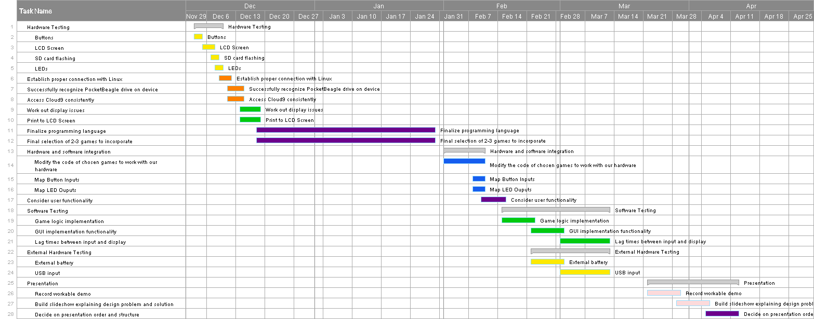

**APPENDIX E: Bill of Materials**

Appendix E: Bill of Materials

|  |  |  |  |  |  |
| --- | --- | --- | --- | --- | --- |
| **Raw Material** | **Quantity** | **Per Unit Cost** | **Total Cost** | **Description** | **Performance Criteria** |
| PocketBeagle | 6 | $27.36 | $164.16 | Tiny, yet complete open source USB-key-fob Linux computer with expansibility | Can communicate with PocketBeagle and read SD card image |
| PocketBeagle GamePup Cape | 6 | $48.00 | $288.00 | Daughter board add-on product that extends PocketBeagle into a handheld arcade emulator; consists of buttons, buzzer, and LCD | Can send signals from buttons to the PocketBeagle, and LED lights and LCD screen are responsive to signals from PocketBeagle |
| LCD Screen | 6 | (Price included with cape) |  | 168 X 128 Color LCD display | Displays clearly and is responsive to code changes |
| Micro USB cable | 6 | (Supplied by team) |  | Cable used to access PocketBeagle | No connection issues between computer and PocketBeagle |
| Micro SD Card | 24 | $5.00 | $120.00 | 16GB micro SD card | Is detectable on computer and allows for use of Cloud9 IDE |
| 3.7V Lithium Ion Polymer Battery | 6 | $17.18 | $103.08 | Allows for portability of the PocketBeagle by providing a mobile power source | Has the correct JST polarity |

**APPENDIX F: User Experience Surveys**

S